COURTYARD - CHURCH Setup Sheet

Please Email this setup to [JHolmgren@oloj.org](mailto:JHolmgren@oloj.org) or print and put it in the Maintenance mailbox.

|  |  |  |  |  |  |  |  |  |  |  |  |  |  |  |  |  |
| --- | --- | --- | --- | --- | --- | --- | --- | --- | --- | --- | --- | --- | --- | --- | --- | --- |
| Date of Event | DATE | thru | DATE | Start Time: | | hr. | | AM PM | Setup must  be ready at: | | | hr. | AM PM | | Day of Week | |
| Name of Event |  | | | | | | | | | Num. of people expected | | | | | |  |
| Organization |  | | | | Contact  person | |  | | | | Phone | | |  | | |
| Special Equip: | Mic Mic stand Podium Audio Cart Screen Easel | | | | | | | | | | | | | | | |
| Other Information: | | | | | | | | | | | | | | | | |

In the boxes below, indicate the number of tables you want and then enter how many chairs per table:

Chair

**Chairs per table**

6'X18" Table

(34 available)

3'X20" Table

(6 available)

6'X30" Table

(18 available)

6' Round Table

(8 maximum)

Umbrella

(8 available)

6' Table with chairs

Trash Can

**T**

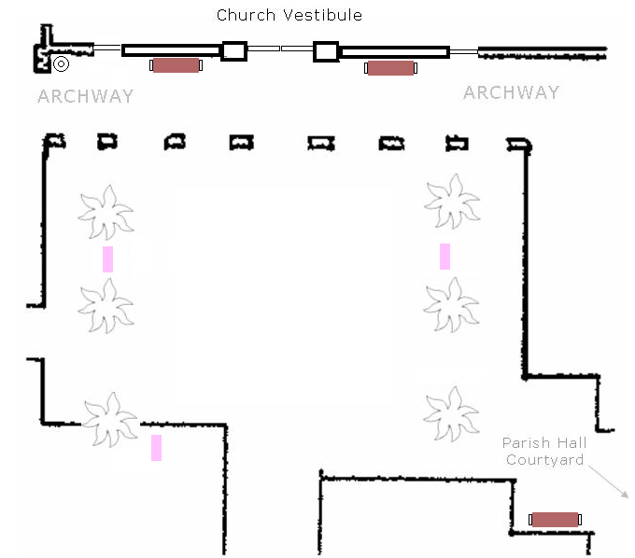

Revised 3/1/14