TEEN CENTER SET UP SHEET
Please Email this setup to JHolmgren@oloj.org or print and put it in the Maintenance mailbox.
Date of Event | DATE | thru | DATE | Start Time: |  | hr. | AM PM | Setup must  be ready at: |  | hr. |  | AM PM |  | Day of Week
Name of Event |  |  |  |  |  |  |  |  | Num. of people expected
Organization |  |  |  |  | Contact  person |  |  |  |  |  | Phone
Special Equip: | ☐Mic ☐Mic stand ☐Dry Erase Board ☐Podium ☐Projector/DVD/CD ☐Audio Cart ☐Screen ☐Easel Pad
Other Information:

In the boxes below, enter the number of tables you want and then enter how many chairs per table:

Chair
By Special Request:

6' x 30" Rectangle Tables

Extra Chairs

Chairs per table

30 chairs available

6' X 18" table

(10 available)

6' round tables
(max. 4 tables)

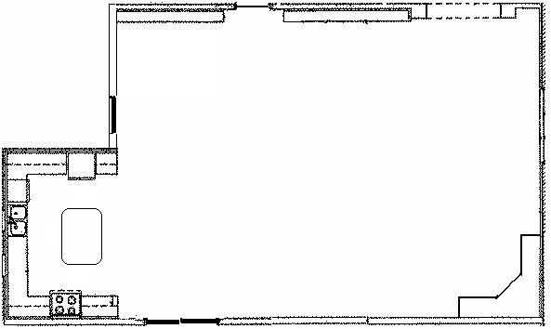
TV & DVD
Rev 4/7/14 by Robert Renwick

