READ ME

New Setup Sheets and Work Order are now available in the Maintenance Folder in the Public Folder on your computer. These Setup Sheets and Work Order can be filled out on your computer and directly emailed to John Holmgren. Please put the name of the event as the Subject. (In case you don’t know how to email the Setup Sheet or Work Order directly, please see page 2*.)

The more information we have about your Setup or Work, the more likely you’ll get the setup you want. So help yourself by helping Maintenance -- be as thorough as you can when filling out these forms.

By the way, if you have already submitted a setup in the past, you can look for it in the “Setups on File” Folder in the Maintenance Folder. Then all you have to do is update the info as necessary and email the (updated) old setup sheet.

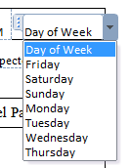
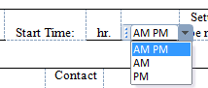
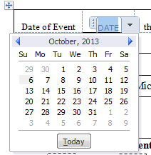
Filling out the first row of information boxes: for your convenience, the first row of boxes – dates and times – are all drop down menus. Just click in the box and a calendar or other menu will drop down for you to select from. All the other information (names, contact numbers, etc.) can be typed in the appropriate box.
Examples:

To indicate what Special Equipment you want, just click in the little box next to it.
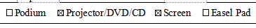
Example:

In the box Additional Setup Details you can enter any additional information Maintenance needs to know about your setup.

Enter the number of tables and how many chairs per table: In the section with the drawings of tables, chair, room divider and trash can, enter the number of each item in the dashed box next to it. Just click in each box and type the number.
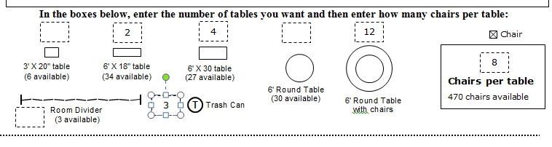
Example:

If you would like to know how to lay out your setup on your computer rather than drawing it by hand, see page 2.**

* Sending emails directly: (This sounds complicated; it’s really easy once you’ve done it.)
As soon as you are finished filling out the Setup Sheet or Work Order, SAVE the Setup Sheet and title it with the Name of Event and the date.

Next click on the FILE tab, and then in the left hand list that appears, click on SAVE & SEND. A list “Send Using E-mail” will appear. Click on the button SEND AS ATTACHMENT.

A blank email will open up. In the “To…” box enter John Holmgren’s email address. In the Subject box, enter the Name of Event. Click “Send”.

That’s it.

** Laying out your setup on your computer.
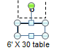
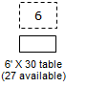
Click on the drawing you want to use in your layout. It will be highlighted with a box with tiny circles in the corners.

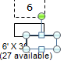
Press and hold the “Ctl” key and then press the “D” (for Duplicate) key. A highlighted duplicate of the drawing will appear.

Click and drag it to the floor plan. Use this duplicate drawing to duplicate as many tables as you want by repeatedly pressing the “Ctl” + “D” key combination.
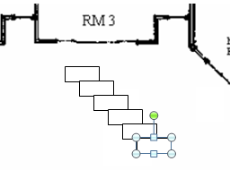

When you have the number of tables you want, simply click each one and drag it into position on the floor plan.

If you want to change a rectangular table’s direction (rotate it), click on the green circle that is above the highlighted drawing, and use that to rotate it.
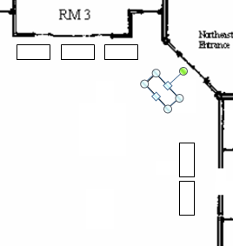
Rotate here

