COURTYARD – PRESCHOOL Setup Sheet
Please Email this setup to JHolmgren@oloj.org or print and put it in the Maintenance mailbox.

Date of Event | DATE | thru | DATE | Start Time: |  | hr. |  | AM PM | Setup must  be ready at: |  |  | hr. | AM PM |  | Day of Week
Name of Event |  |  |  |  |  |  |  |  |  | Num. of people expected
Organization |  |  |  |  | Contact  person |  |  |  |  |  | Phone
Special Equip: | ☐Mic ☐Mic stand ☐Podium ☐Audio Cart ☐Screen ☐Easel
Other Information:

In the boxes below, indicate the number of tables you want and then enter how many chairs per table:

Chair

Chairs per table

6'X18" Table
(34 available)
3'X20" Table
(6 available)
6'X30" Table
(18 available)

6' Round Table
(8 maximum)

Umbrella
(8 available)

6' Table with chairs
Trash Can

T

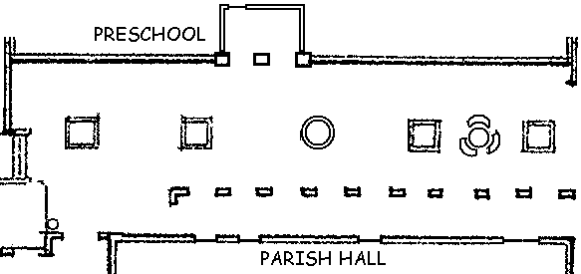
Revised 3/1/14
ARCHWAY

