SET UP SHEET FOR MAIN PARKING LOT
Please Email this setup to JHolmgren@oloj.org or print and put it in the Maintenance mailbox.

Date of Event | Date | thru | Date | Event  Start Time: |  | 8 |  | AM PM | Setup must  be ready at: |  |  | hr. | AM PM |  | Day of Week
Name of Event |  |  |  |  |  |  |  |  |  | Num. of people expected
Organization |  |  |  |  | Contact Person |  |  |  |  |  | Phone
Special Equip: | ☐Cones ☐Barricades ☐Audio Cart ☐Other speakers ☐6'X18" Tables ☐6'X30" Tables ☐Chairs
Other Information:

Please indicate below what you are planning for the Main Parking Lot:
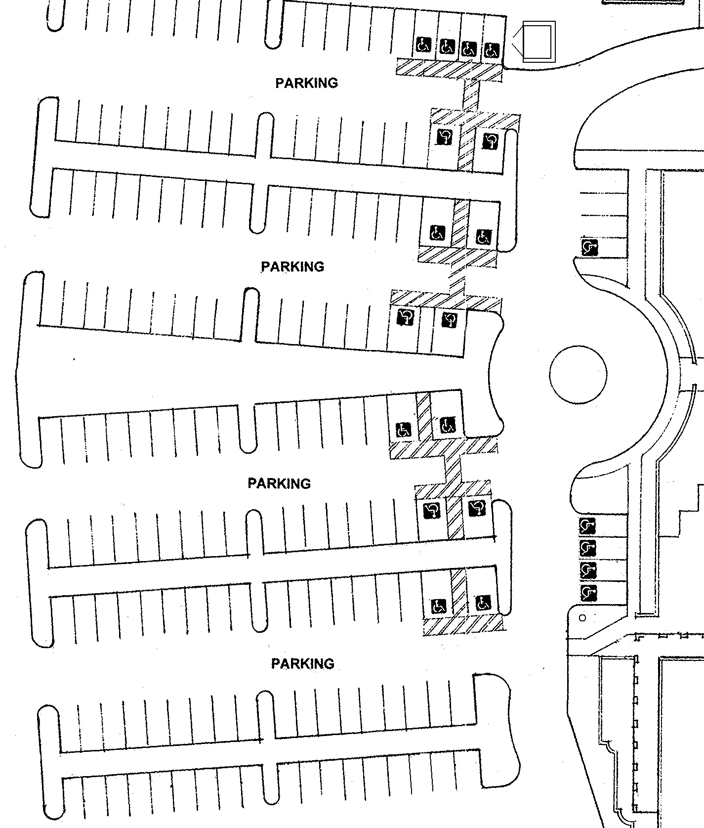
Parish Hall Courtyard
Church Courtyard
PARISH HALL

Revised 4/26/14 by Robert Renwick

