PARISH HALL – MAIN SET UP SHEET
Please Email this setup to JHolmgren@oloj.org or print and put it in the Maintenance mailbox.

Date of Event | DATE | thru | DATE | Start Time: |  | hr. |  | AM PM | Setup must  be ready at: |  |  | hr. | AM PM |  | Day of Week
Name of Event |  |  |  |  |  |  |  |  |  | Num. of people expected
Organization |  |  |  |  | Contact  person |  |  |  |  |  | Phone
Special Equip: | ☐Mic ☐Mic stand ☐Lavellier ☐Podium ☐Projector/DVD/CD ☐Screen ☐Easel Pad ☐Easel
Additional Setup Details:

In the boxes below, enter the number of tables you want and then enter how many chairs per table:
Chair

6' X 30 table
(27 available)

Chairs per table

470 chairs available

3' X 20" table
(6 available)
6' X 18" table
(34 available)

6' Round Table
(30 available)

T
Trash Can

6' Round Table
with chairs
Room Divider
(3 available)

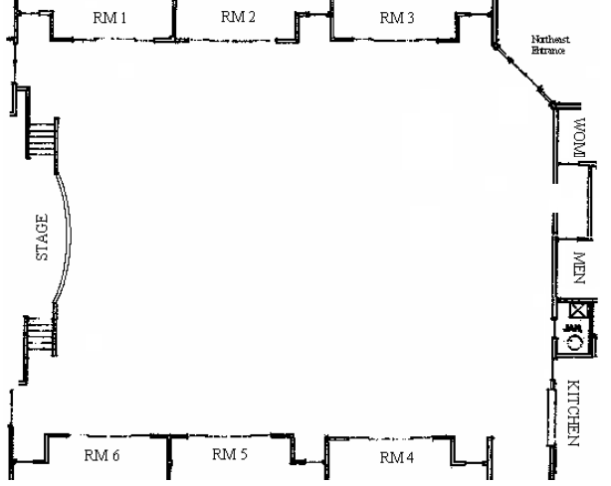
Revised 3-23-13 by Robert Renwick

