CHURCH VESTIBULE SET UP SHEET

Please Email this setup to JHolmgren@oloj.org or print and put it in the Maintenance mailbox

Date of Event | DATE | thru | DATE | Start Time: |  | hr. |  | AM PM | Setup must  be ready at: |  | hr. | AM PM |  | Day of Week
Name of Event
Organization |  |  |  |  | Contact  person |  |  |  |  | Phone
Special Equip: | ☐ Table 2' x 4' ☐ Table 6' x 18" ☐ Table 6' x 30" ☐Easel
Additional Information:

In the boxes below, enter the number of tables you want:

6' X 30" Table

6' X 18" Table

3' X 20" Table

NAVE

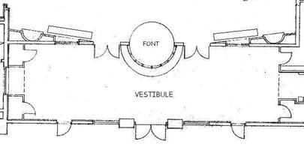
Revised 4/7/14 by Robert Renwick
CHURCH COURTYARD

