CHURCH SANCTUARY SET UP SHEET
Please Email this setup to JHolmgren@oloj.org or print and put it in the Maintenance mailbox.

Date of Event | DATE | thru | DATE | Start Time: |  | hr. |  | AM PM | Setup must  be ready at: |  |  | hr. | AM PM |  | Day of Week
Name of Event |  |  |  |  |  |  |  |  |  | Num. of people expected
Organization |  |  |  |  | Contact  person |  |  |  |  |  | Phone
Additional Setup Details:

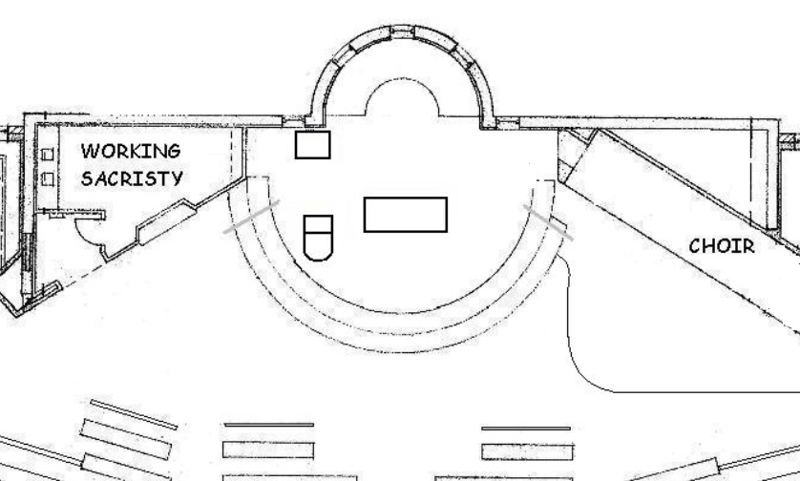
Revised 3/9/14

