CHURCH ENTIRE SET UP SHEET
Please Email this setup to JHolmgren@oloj.org or print and put it in the Maintenance mailbox.

Date of Event | DATE | thru | DATE | Start Time: |  | hr. |  | AM PM | Setup must  be ready at: |  | hr. | AM PM |  | Day of Week
Name of Event
Organization |  |  |  |  | Contact  person |  |  |  |  | Phone
Additional Setup Details:

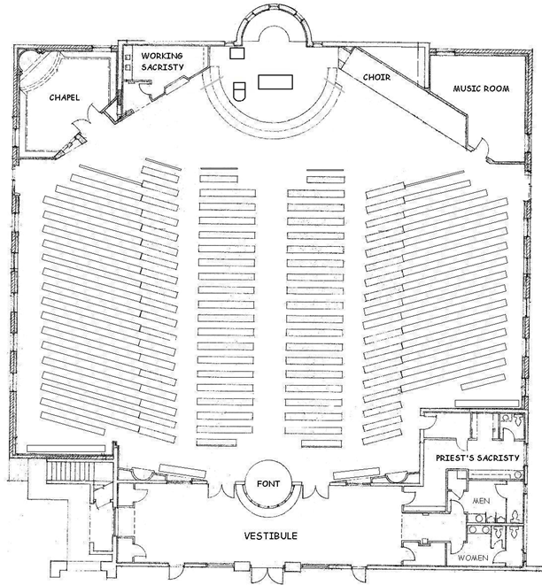
Revised by 4/7/14 by Robert Renwick

